Foot Valve
Operation Manual
Purpose: This valve is installed at the bottom end of a pump suction pipeline. It automatically prevents fluid backflow.
Performance Specifications:
Model | Nominal Diameter DN (mm) | Nominal Pressure PN (MPa) | Test Pressure (MPa) |  | Operating Temp. | Suitable Media
 |  |  | Strength | Sealing
H42X-2.5 | 50 ~ 350 | 0.25 | 0.4 | 0.28 | ≤50°C | 50
Structure:
3.1 The basic structure of this valve is shown in Figure 1.
3.2 Rubber sealing rings are used, providing reliable sealing performance.
Operating Principle:
The valve opens and closes automatically based on the flow of the medium itself, preventing backflow when the pump is stopped.
Storage, Maintenance, Installation, and Use:
5.1 Valves shall be stored indoors in a dry and ventilated area, with both pipeline openings sealed.
5.2 Valves stored for extended periods shall be inspected regularly; debris shall be removed. Pay special attention to keeping the sealing faces clean to prevent damage.
5.3 Before installation, verify that the valve markings match the requirements.
5.4 Before installation, inspect the valve interior and sealing faces; if any contaminants are present, wipe clean with a soft cloth.
5.5 The valve shall be installed on a vertical pipeline.
Possible Faults, Causes, and Resolutions — See Table:
Table Possible Faults, Causes, and Resolutions
Possible Fault | Cause | Resolution
Leakage at body-cover joint | 1. Uneven tightening of connecting bolts  2. Damage to flange sealing surface  3. Gasket rupture or failure | 1. Tighten evenly  2. Recondition / Refinish  3. Replace with a new gasket
Valve noisy / vibrating | 1. The valve is installed too close to the pump  2. Unstable flow pressure of medium in the pipeline | 1. Reinstall to a proper position  2. Eliminate pressure fluctuation
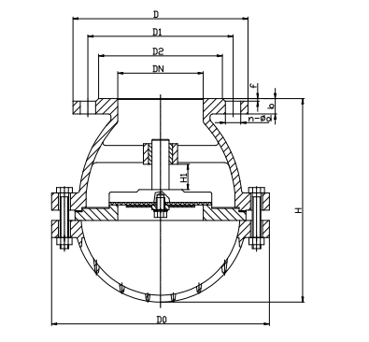
Figure 1 Foot Valve


WEIZIDOM GROUP
www.wsdvalves.com
South City, Longhu Town, Xinzheng City,
Zhengzhou City, Henan Province, China

